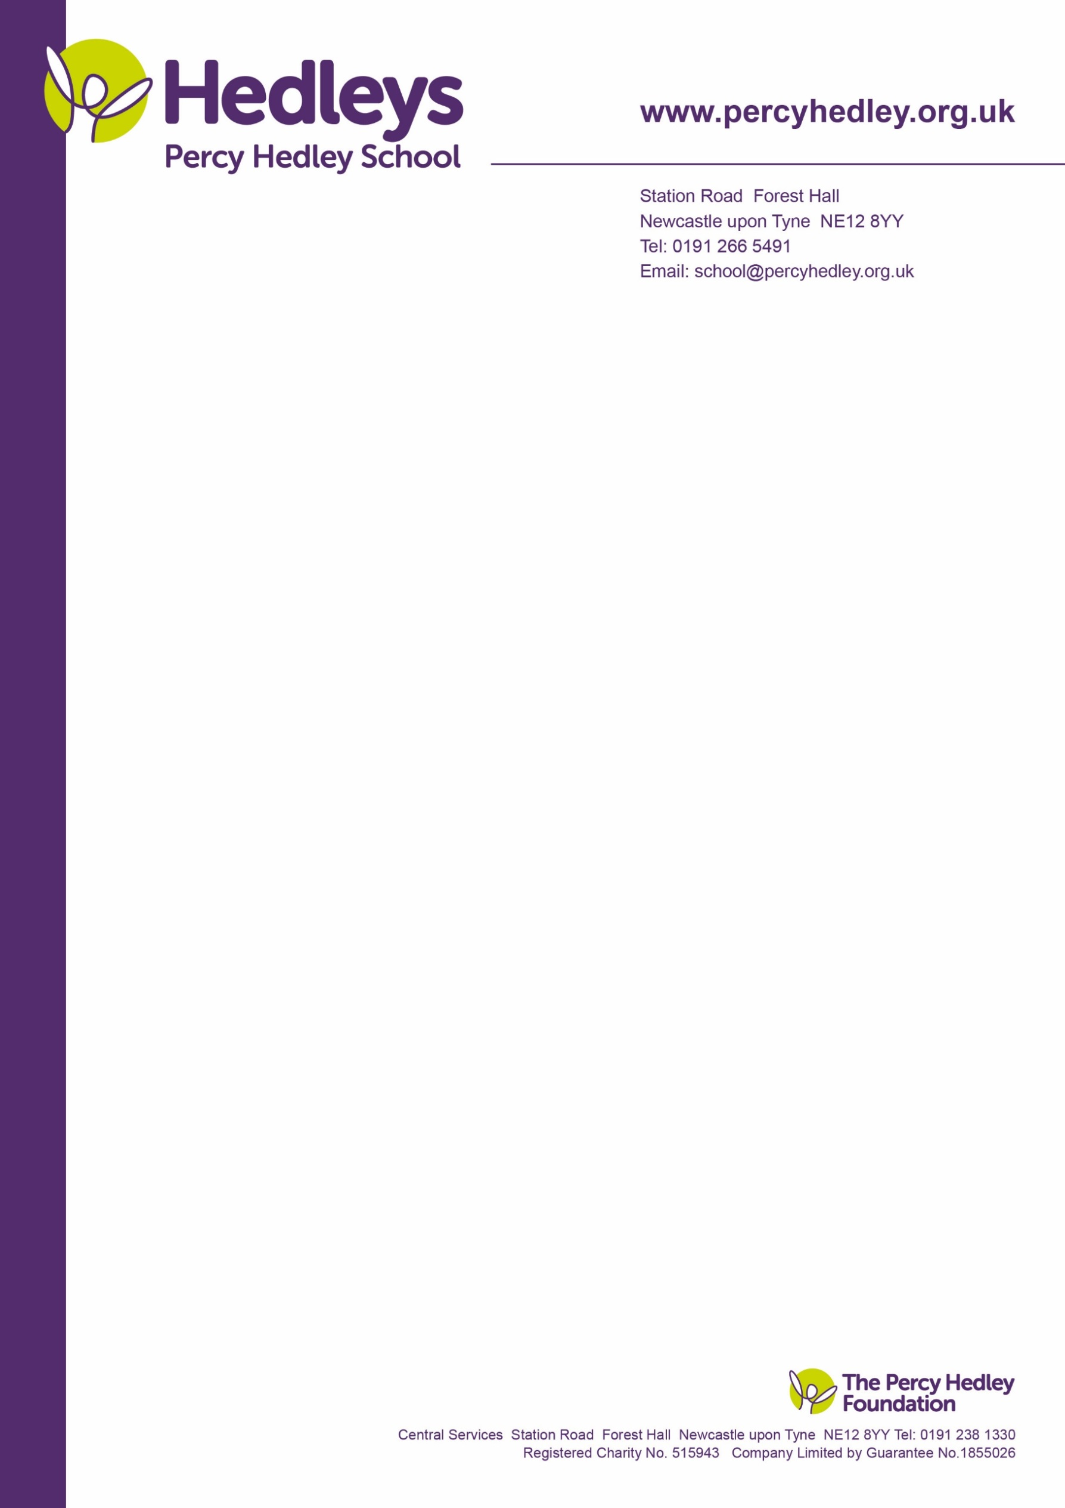

20 March 2023

Dear parent/carer,

I would like to invite you to a social coffee morning on Wednesday **29th March from 9.30-11.00.** The aim is to enable parents/carers to get together and meet with me and you have told me that these are enjoyable and useful.100% noted the best part was meeting and talking to other parents. Class teams will not be attending; they organize class/departmental events separately.

As always, I am constantly seeking to improve on ways I communicate with and support parents/carers. I would welcome your thoughts and suggestions by email, phone or at the coffee morning.

Although the time of the meeting is 9.30-11 you are welcome to drop in at any time within the time frame and leave early if needed. As I also work with the PTA, I will be asking for your thoughts on our proposed change from a PTA to Friends of Percy Hedley School.

Please could you complete and return the slip below as I do need accurate numbers for catering purposes?

Yours sincerely

Eileen Robinson

Family Liaison Officer

Email: [e.robinson@percyhedley.org.uk](mailto:e.robinson@percyhedley.org.uk)

Telephone: 0191 2161811 ext 3260.

------------------------------------------------------------------------------------------------------------------------------------------------

Please cut on dotted line and return fao E Robinson by Monday 27th March. Alternatively email me.

Names of parent/carers who will be attending:

_______________________________________________________________________________________

Your child/young person’s name:_________________________________________________________

Your child/young person’s class: ___________________________

If unable to attend, please state reason why and if a different day/time would suit better:

_______________________________________________________________________________________

Any comments:

West Lane, Killingworth

Newcastle upon Tyne, NE12 7BH

Tel: 0191 216 1811

Email: school@percyhedley.org.uk