Higher Level Support Worker
Service: | Hedleys Horizons
Responsible To: | Activity Lead / Programme Manager
Salary: | Points 6 - 11

Job Purpose
Supporting with and initiating vocational, social and leisure activities as appropriate. Setting up and delivering activities for individuals and groups ensuring they are involved at all times.

Main Duties
- To give clear direction and include support staff in sessions at all times. Taking the lead role in the group in the absence of the Activity Lead.
- To be involved with the creation and implementation of Individual Programme Plans, taking into account the outcomes, ambitions and personal choice od service users.
- To establish a good working relationship with service users and their families, including home visits, if appropriate.
- To attend reviews and participate in meetings as required internally and with external professionals.
- To maintain a record of activities and other general administrative duties as requested
- To escort service users as necessary, this includes driving the Foundation’s vehicles (where a valid driving licence is held).
- To record and report all accidents and incidents when necessary.
- To coach and mentor support staff ensuring high standards and outstanding practice.
- To support the Activity Lead with the running of the group and support service users.
- To participate and collaborate in the planning and implementation of programmes and/or topic based approaches where required. This will include the regular planning and leading of sessions in order to release the Activity Lead when required.
- To assist in areas of personal care appropriately.
- To collect and administer prescribed medication and carry out some clinical procedures, where necessary with appropriate training, as instructed by the nurse.
- To be actively involved in personal development such as on and off site training, specifically when required to meet the needs of service users, attending regular staff meetings and contributing to reports when necessary.
- To establish and maintain good working relationships with all professionals both within the teams and those visiting.
- To carry out any other duties reasonably requested by the senior team.

Person Specification

Essential Criteria
Skills and Knowledge
- An awareness of health & safety/ safe working practices
- Willing to implement the safeguarding and equality and diversity agenda
- Ability to empathise with the needs of disabled people
- Good communication skills

Qualifications and Training
- Willingness to undertake further qualifications and any in service training appropriate to the role
- Excellent literacy & numeracy skills.

Experience
- Wide experience of supporting service users with PMLD, HI or autism
Personal Qualities
- Flexible
- Team Worker
- Positive attitude and enthusiasm
- Willingness to learn and be guided by other staff
- Committed to providing high standards of service
- Ability to mentor and coach other support staff with respect

Desirable Criteria
Skills and Knowledge
- Working with people who have complex needs
- Person centred approaches
- Sensory approaches

Qualifications and Training
- Level 2 signing (BSL) or above
- NVQ 2/3

Organisational Standards
The Percy Hedley Foundation operates in a demanding and often changing environment. Members of staff must be flexible, adaptable, willing to face up to changing circumstances and new opportunities. The following list of duties and responsibilities must therefore be taken as a guide and is not to be comprehensive.

Professional Duties
- Participate in the review of the Foundations Policies, Procedures and Processes.
- Participate in arrangements for the performance development review process.
- Participate in arrangements for further training and professional development.
- Keep up to date with changes or developments within your professional area.
- Fully participate in the induction and training programme provided by the Percy Hedley Foundation.
- Contribute to the professional development of other staff, including the induction of new staff.

Equality and Diversity
- Promote equality of access to education, training, and employment opportunities for disabled people, and advocate a positive attitude.
- Recognise that disabled people are individuals who have specific needs
- Employ support strategies that will empower disabled people.
- Show awareness of knowledge and display non-discriminatory behaviours at all times in relation to culture, race, ethnicity, disability, gender, sexuality, and age.
- Recognise the importance of inclusion by using appropriate means of communication at all times.
- Be flexible, trying to meet the changing needs of both disabled people and environment.

Discipline, Health and Safety
- Adhere to and promote Percy Hedley Foundation Health, Safety and Welfare policy at all times.
- Purchase equipment from a recognised source.
- Report all incidents and accidents to Health and Safety Officer
- Maintain a high standard of record keeping in line with Percy Hedley Foundation policies and procedures.

Safeguarding
- Safeguarding is everyone’s responsibility.
- Percy Hedley Foundation have adopted recruitment and selection procedures, and other Human Resource Management processes, that help deter, reject, or identify people who might abuse vulnerable children/adults, or are otherwise unsuited to work with them.
- The Trustees/Governing Body are committed to promoting the welfare of children and young people/adults and staff are expected to ensure that the highest priority is given to following guidance and regulations to safeguard those in our care.

Confidentiality
- Respect confidentiality. All personal information about people using the foundations services to which you have access should be treated as confidential. Information about the people’s needs, progress and assessment should only be shared with the team to aid support.
- Remain objective and do not favour any gender, language or culture and comply with the Percy Hedley Foundation policy.

About Us

We are an ambitious, entrepreneurial, and innovative charitable business working in a person-centred way to meet the needs of people with disabilities and their families. We provide a range of high-quality services and seek out opportunities to inspire and support people with disabilities to achieve their ambitions. We believe that working together as one Foundation we achieve more than individual services would achieve alone. Our influence will be regional, national & international.

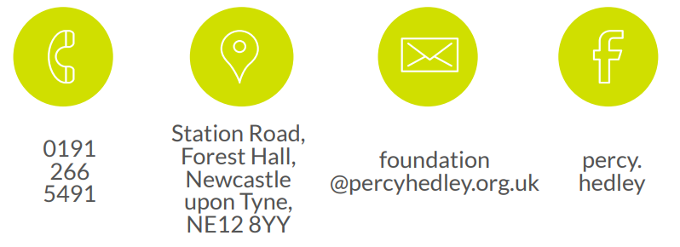
We are committed to safeguarding and promoting the welfare of children, young people, and vulnerable adults. Applicants should be aware that the post will only be offered to successful candidates subject to an Enhanced DBS check as well as other employment clearances.

