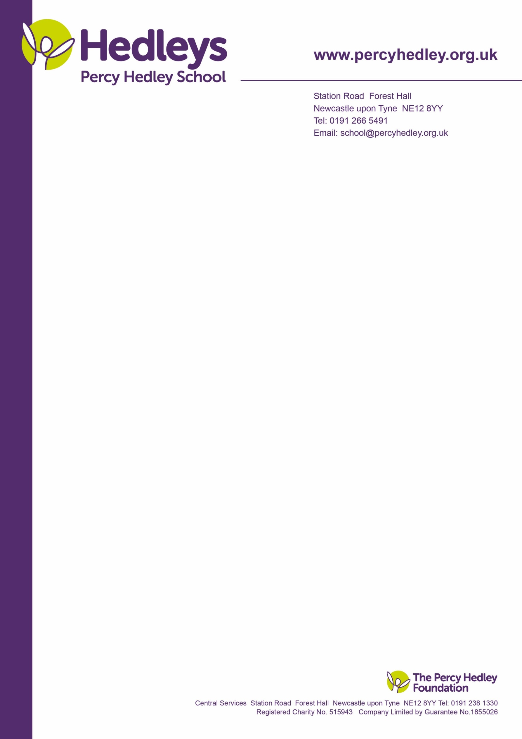



Dear parent/carer,

Welcome to our new school year and a special one to those new to school. I would like to invite you to a social coffee morning on **Wednesday 18th September** **from 9.30-11**.**00** where you will also meet some of the FoPHS committee. These social coffee mornings are a way of bridging the gap between home and school. I am conscious of the wide area we cover. Unlike mainstream schools, most of our students are not living near their classmates and this is a good way to make connections with other parents/carers. My coffee mornings and the FoPHS meetings will, as many of you requested be held on different days/times to enable you to attend. You will find term dates and event notifications on the school website. Link below:

<https://www.percyhedley.org.uk/percy-hedley-school/parent-and-carers/>

What parents have told me is that they value talking to other parents, sharing experiences and tips. As a former Percy Hedley School parent myself I know how much I learned from meeting other parents; you are all experts in your own right and it may help to talk to others.

You can join us for all/part of the session and there will be cake!

Could I also ask those who are willing and able to sponsor my husband and daughter who are doing the Great North Run on Sunday 8th September to raise funds for the Friends of Percy Hedley School? The link is below, or donations can be sent into school for my attention. No amount is too small.

<https://www.justgiving.com/page/richard-robinson-1719428991952>

Please complete and return the section below, as I need numbers for sign in and catering purposes.

Best wishes

Eileen Robinson

Family Liaison Officer

Email: [e.robinson@percyhedley.org.uk](mailto:e.robinson@percyhedley.org.uk)

Telephone: 0191 2161811 ext 3260.

------------------------------------------------------------------------------------------------------------

Please return fao Eileen Robinson no later than **Friday 14th September**. (add comments if desired)

I will/will not be attending the coffee morning on Wednesday 18th September (delete as appropriate)

Name/s of those attending:

Special dietary requirements:

Your child’s name and class:

West Lane, Killingworth

Newcastle upon Tyne, NE12 7BH

Tel: 0191 216 1811

Email: e.robinson@percyhedley.org.uk

6th September 2024