Admin Assistant
Service: | Horizons
Responsible To: | Lead Admin
Salary: | Points 5-6

Job Purpose
To be Front Of House and first point of contact for all service users, colleagues & visitors to Horizons. To provide a fully comprehensive reception and administrative function.

Main Duties
- To maintain a secure environment following safe practice and procedures
- To support foundation finance systems by taking a lead role in relevant ordering and invoices.
- To maintain accurate records within service user databases and personnel filing systems.
- To effectively manage the switchboard, handle calls appropriately and record/take messages accurately distributing accordingly
- To provide an efficient and courteous reception service to include the signing in/out of visitors and preparation of fire registers
- To take responsibility for the reception area, ensuring it is kept clean and tidy, literature is displayed and is accurate/kept up to date
- To order, monitor and maintain stationery stock levels in the service. This to include audit checks and replenishment
- To be responsible for the speedy and accurate distribution of deliveries received in reception
- To carry out filing, photocopying and typing in an efficient manner. To include handling sensitive and/or confidential data professionally and securely under the direction of the Lead Administrator
- Any other reasonable duties requested by the Lead Administrator and/or the Leadership Team

Person Specification

Essential Criteria
Skills and Knowledge
- Ability to deal with incoming calls appropriately
- Ability to produce letters and reports using word processing software
- Ability to set up and use spreadsheets
- Strong communication skills both written and verbal
- Ability to prioritise and perform tasks in accordance with timetable.
- High levels of literacy and numeracy

Qualifications and Training
- Relevant NVQ 3 or RSA 3 qualification

Experience
- Administration within a busy office environment
- Experience of working on a busy switchboard
- Experience of using databases
Personal Qualities
- Good telephone manner
- Professional/committed
- A team player
- Enthusiastic
- Positive and confident manner
- Able to work unsupervised
- Willingness to contribute to other areas of work according to team priorities
- Able to work flexibly

Desirable Criteria
Skills and Knowledge
- Ability to use Microsoft Office software
- Ability to produce Mail Merge documents
- Ability to produce accurate records of meetings
- Shorthand skills to assist with note taking at meetings etc.
- Awareness of equality and diversity issues

Qualifications and Training
- Maths & English GCSE

Organisational Standards
The Percy Hedley Foundation operates in a demanding and often changing environment. Members of staff must be flexible, adaptable, willing to face up to changing circumstances and new opportunities. The following list of duties and responsibilities must therefore be taken as a guide and is not to be comprehensive.

Professional Duties
- Participate in the review of the Foundations Policies, Procedures and Processes
- Participate in arrangements for the performance development review process
- Participate in arrangements for further training and professional development
- Keep up to date with changes or developments within your professional area
- Fully participate in the induction and training programme provided by the Percy Hedley Foundation
- Contribute to the professional development of other staff, including the induction of new staff.

Equality and Diversity
- Promote equality of access to education, training, and employment opportunities for disabled people, and advocate a positive attitude
- Recognise that disabled people are individuals who have specific needs
- Employ support strategies that will empower disabled people
- Show awareness of knowledge and display non-discriminatory behaviours at all times in relation to culture, race, ethnicity, disability, gender, sexuality, and age
- Recognise the importance of inclusion by using appropriate means of communication at all times
- Be flexible, trying to meet the changing needs of both disabled people and environment.

Discipline, Health and Safety
- Adhere to and promote Percy Hedley Foundation Health, Safety and Welfare policy at all times
- Purchase equipment from a recognised source
- Report all incidents and accidents to Health and Safety Officer
- Maintain a high standard of record keeping in line with Percy Hedley Foundation policies and procedures.

Safeguarding
- Safeguarding is everyone’s responsibility.
- Percy Hedley Foundation have adopted recruitment and selection procedures, and other Human Resource Management processes, that help deter, reject, or identify people who might abuse vulnerable children/adults, or are otherwise unsuited to work with them.
- The Trustees/Governing Body are committed to promoting the welfare of children and young people/adults and staff are expected to ensure that the highest priority is given to following guidance and regulations to safeguard those in our care.

Confidentiality
- Respect confidentiality. All personal information about people using the foundations services to which you have access should be treated as confidential. Information about the people’s needs, progress and assessment should only be shared with the team to aid support
- Remain objective and do not favour any gender, language or culture and comply with the Percy Hedley Foundation policy.

About Us

We are an ambitious, entrepreneurial, and innovative charitable business working in a person-centred way to meet the needs of people with disabilities and their families. We provide a range of high-quality services and seek out opportunities to inspire and support people with disabilities to achieve their ambitions. We believe that working together as one Foundation we achieve more than individual services would achieve alone. Our influence will be regional, national & international.

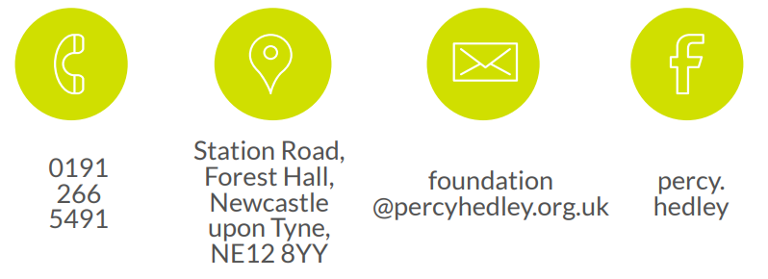
We are committed to safeguarding and promoting the welfare of children, young people, and vulnerable adults. Applicants should be aware that the post will only be offered to successful candidates subject to an Enhanced DBS check as well as other employment clearances.

